KPI’s

Find total Revenue of Pizza Sales:

select SUM(total_price) AS Total_Revenue from pizza_sales

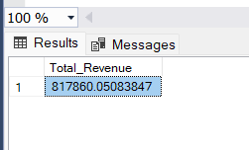

2. Average Order Value:

Select SUM(total_price) / COUNT(DISTINCT order_id) AS Avg_order_value from pizza_sales

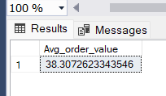

3. Total Pizza Sold:

SELECT SUM(quantity) AS Total_pizza_sold from pizza_sales

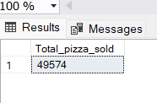

4. Total orders:

SELECT COUNT(DISTINCT order_id) AS Total_orders from pizza_sales

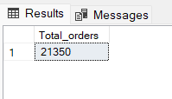

5. Average Pizza per order:

SELECT SUM(quantity) / COUNT(DISTINCT order_id) AS Avg_order from pizza_sales

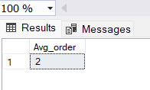

Including decimal values:

SELECT CAST(SUM(quantity) AS DECIMAL(10,2)) /

CAST(COUNT(DISTINCT order_id) AS DECIMAL(10,2)) from pizza_sales

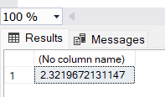

Total orders per day(daily trend):

select DATENAME(DW, order_date) as order_day, COUNT(DISTINCT order_id) AS total_order from pizza_sales

GROUP BY DATENAME(DW, order_date)

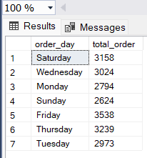

Orders per month (montly trend):

Select DATENAME(MONTH, order_date) AS Month_Name, COUNT(DISTINCT order_id) from

pizza_sales

GROUP BY DATENAME(MONTH, order_date)

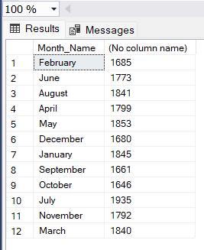

Percentage of sales of pizza category:

SELECT pizza_category, SUM(total_price)* 100 / (SELECT SUM(total_price)

from pizza_sales) AS PCT_sales from pizza_sales

GROUP BY pizza_category

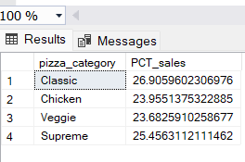

Total sales and PCT:

SELECT pizza_category, SUM( total_price) AS total_sales, SUM(total_price)* 100 / (SELECT SUM(total_price)

from pizza_sales) AS PCT_sales from pizza_sales

GROUP BY pizza_category

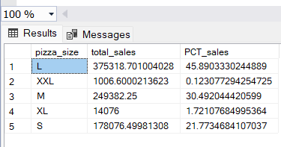

Top 5 Pizza by Revenue:

SELECT top 5 pizza_name, SUM(total_price) AS total_Revenue FROM pizza_sales

GROUP BY pizza_name

ORDER BY total_Revenue DESC

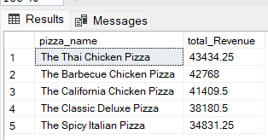

Bottom 5 pizza by Revenue:

SELECT top 5 pizza_name, SUM(total_price) AS total_Revenue FROM pizza_sales

GROUP BY pizza_name

ORDER BY total_Revenue ASC

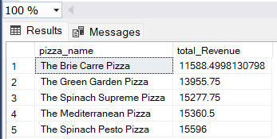

Top 5 pizza by Quantity:

SELECT top 5 pizza_name, SUM(quantity) AS total_quantity FROM pizza_sales

GROUP BY pizza_name

ORDER BY total_quantity DESC

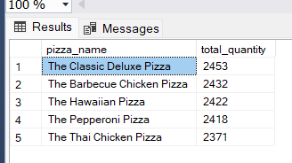

Bottom 5 pizza by quantity:

SELECT top 5 pizza_name, SUM(quantity) AS total_quantity FROM pizza_sales

GROUP BY pizza_name

ORDER BY total_quantity ASC

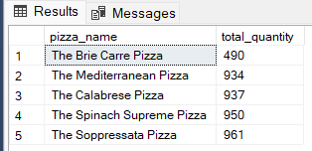

Top 5 pizza name by total order:

SELECT top 5 pizza_name, COUNT(DISTINCT order_id) AS total_orders FROM pizza_sales

GROUP BY pizza_name

ORDER BY total_orders DESC

